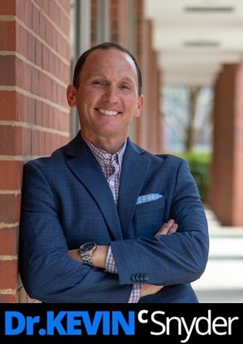
Customization questions for your upcoming event!

Receiving your feedback and insight about your event and organization help me customize my content to ensure an engaging, dynamic and relevant presentation for the audience. The more information you can provide the better, as each presentation is customized based on your objectives, theme and group in mind. Anything you share with me is confidential. After I review your feedback from this document, we’ll set up our first customization phone call.

Multiple people are encouraged and welcome to share information with me. Please download this document, type your answers onto it, and attach the document to an email addressed to me. Thank you! (Kevin@KevinCSnyder.com)

About the Event

Generally speaking what is the overall purpose for the entire event? Your intended goals?

Event description in 1-3 sentences:

Event purpose:

Top goal priority #1:

Top goal priority #2:

How does my speech fit within the entire scope of the event? If you have a schedule or agenda for the event already, please email me the schedule link or attachment so I have a better understanding of how I fit into the event.

Do you have an event theme?

Please share anything else about the event that you feel would be helpful for me to know:

About the Attendees

Describe who will be in attendance:

List some of their titles and any major departments/positions represented:

How many attendees do you expect to attend my presentation?

Do attendees choose to attend or are they required?

Generally speaking, what gets your employees/attendees excited and passionate about their role and
working in your industry? “Why” do they do what they do?

Generally speaking, what are 2-3 common challenges and/or frustrations that employees/attendees
might currently be facing in their role?

Please share anything else about the attendees helpful for me to know:

About Your Organization (again, this is all confidential!)

What makes your organization unique and awesome?

Do you have any main competitors? If so, list 2-3 below and share what makes you all unique, better, and different:

Looking back on the past year, what pivotal events, accomplishments, or setbacks come to mind? (again, this is all confidential!)

Are there any specific goals for your organization in the next year and 3-5+ years?
Next year goal(s):

3-5+ year goal(s):

Tell me more about any primary challenges that your organization faces specifically. Feel free to be specific or general.

Are there any common buzzwords, acronyms, or phrases that people in your organization use regularly?

Are there any common buzzwords, acronyms, or phrases that people in your organization use regularly that I should avoid?

Please share anything else helpful to know about your organization that I might not otherwise:

About My Specific Presentation

Please confirm date, time, location, and length for my presentation.
Date:
Time:
Location & room:
Length:
(note: regardless of when I’m introduced, I will end on time!)

What are 2-3 most important goals you have for my presentation overall?

List 2-3 of the most important actionable take-a-ways (i.e. objectives) you would like for attendees to leave with after my presentation? Meaning, what would you like for them to know, feel and/or do once they leave your event and return home?

Please share anything else about how I can customize my presentation so it’s engaging and relevant for the audience:

Other Helpful Information to Know
Is there an event hashtag you’re using? If so, please list below.

Thinking about some of the best speakers you’ve brought in for this event in the past, what was it about their presentation that made them so darn good?

Thinking about some of the “not-so-good speakers” you may have seen or brought in for this event in the
past, what was it about their presentation that made them not so good?

Besides religion, politics, and using any foul language, are there any sacred cow issues or topics that I
should avoid? (note: my speeches are never controversial and I don’t use foul language … it’s just helpful to
know in advance if there are any topics I should make a point to avoid. We can discuss this during our call as
well!)

Is there a break before or after I present?
(note: If you have an agenda, please send a copy to me. I do recommend a break just before my presentation
so we can ensure proper set up and sound check. See my AV/technical requirements available on my website
– or click here. I also recommend a break after my keynote for book signing and meet and greet.)

Are you recording my presentation or having a photographer onsite? If not, I recommend it!
(note: I am agreeable with you professionally recording my presentation so you can use clips throughout the year and/or taking photos. All I request is a copy of any files afterward.)

Note: I am happy to provide you and attendees with a copy of my presentation slide deck, handout(s), and links to any of my leadership content referenced in my presentation.

** Please email this document back to me at Kevin@KevinCSnyder.com. When you email me, please share 2-3 convenient times we can speak on the phone to discuss your event in more detail. Anyone is welcome to join our call.

~ Thank you ~
Please contact me for any questions. I look forward to your event!
Kevin@KevinCSnyder.com
#919-633-9931 (cell)

